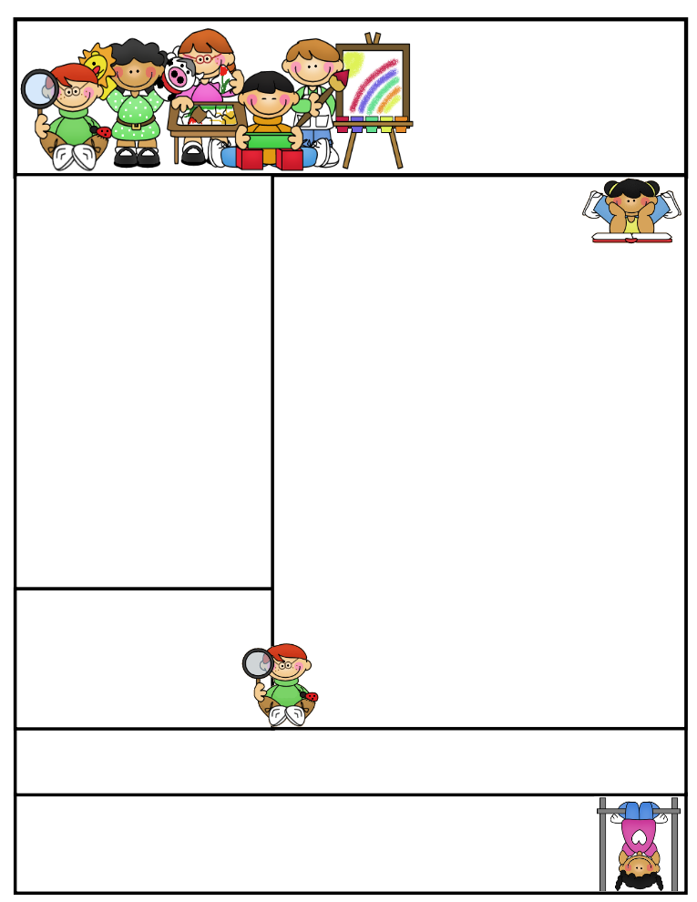

Important Dates

**Hajj Re-enactment**

Tuesday, September 22, 2015

Children can wear Jubbahs or Abayahs

**Eid ul-Adha Holiday**

Thursday, September 24, 2015

**Meet the Teacher Night**

Wednesday, September 30, 2015

Coming to School and Dismissal

School beings at **8:20 a.m**. Please arrive at school by 8:15 a.m. Drop your child off at the school entrance doors.

Dismissal is at **3:30 p.m.** Please wait for your child to leave the classroom and pick him/her up downstairs by the entrance doors at the end of the day. Students that are not picked up by 3:35 will be dropped off to Sr. Zohra in the cafeteria for afterschool care. Please note that there is a $ 3 per day charge for this service.

**If your child needs to leave early for any reason, please send a signed note stating the reason for early release and inform the office.

Welcome Back!

**As-Salaamu-Alaikum,**

Welcome to Grade 1, alhumdulillah! School has begun and we hope to have an exciting year!

I am so excited to be your child’s teacher as they embark on this new adventure. As a new member of the Islamic Foundation team, it’s a new adventure for me as well! I wanted to take this opportunity to introduce myself to you. My name is Sana Siddiqui and this will be my fourth year teaching at IFS. I am excited about working with your child and learning from each other.

This is a very special year in your child’s schooling! First grade is a time to experience important transitions and acquire new skills. During the year, your child will learn how to read, write stories, add, subtract, and so much more. Insha-Allah, I hope to instill a love of learning that will last throughout your child’s years of schooling and beyond!

During this first week of school we will be spending time getting to know each other and establishing routines for the class, insha-Allah. Some of our friends in grade 1 are new to the school and some are returning students. We will be working together to build a learning community that fosters mutual respect, builds Islamic character and encourages each child to challenge him/herself to make the best effort possible, insha-Allah.

Check us out on the web! Go to www.myifs.ca/grade1A to see latest updates, pictures of our class, helpful hints and much more!

Sr. Sana Siddiqui **sanasiddiquiali@gmail.com**  
Islamic Foundation www.myifs.ca  
441 Nugget Ave.  
416 321-3776

Grade One  
Newsletter

September 8, 2015

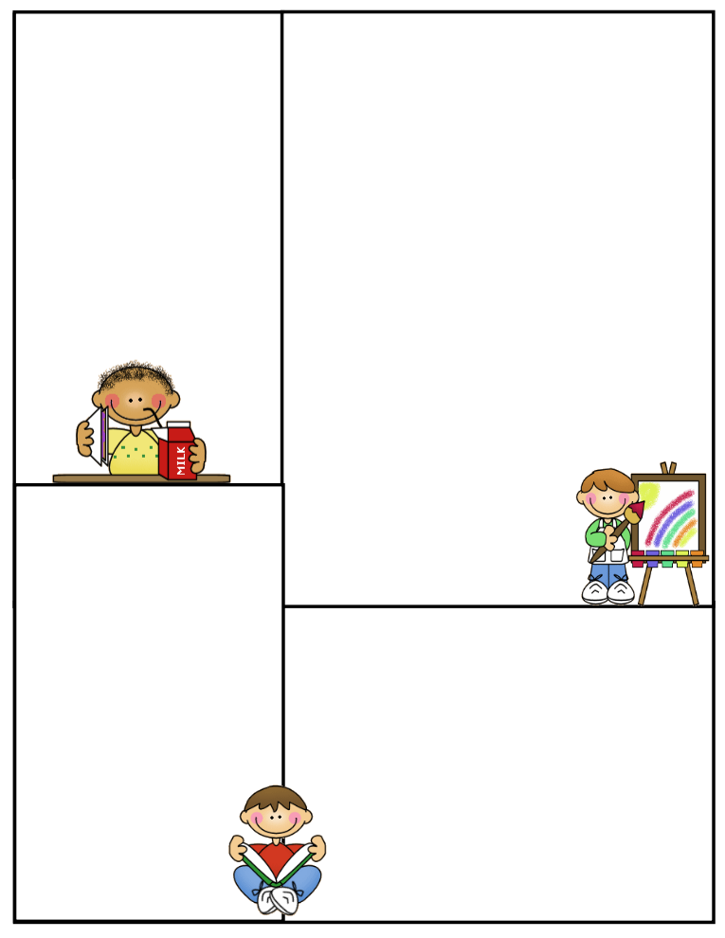

Lunch on Fridays

On Fridays, children can bring $5 to purchase the following items: Krispy’s Chicken and Fries, Popeye’s Chicken Burger, or Biryani. Pizza slices can be purchased for $2.50. Bottled water can be purchased for 50 cents.

Treats

If you would like to send treats for the class in celebration of a special day or simply for the sake of sharing, please send 30 pre-packaged items or finger foods. Please refrain from sending cakes or big bags of chips. Unfortunately, serving these items takes away from our precious learning time and our planned activities for the day.

Homework Policy

All homework is a reinforcement or extension of class instruction. A letter will be sent home next week regarding the homework folder.

Someone at home should be available to help your child go over directions and make sure work is completed independently and returned to school.

Classroom Rules

As a Tribes community classroom, we believe in positive “agreements” or rules to ensure a safe learning and optimal learning environment. Children are expected to follow the four basic agreements to the best of their ability:

1. Attentive listening
2. Mutual respect
3. Appreciations – no put downs
4. The right to pass – participate

Gym

Our class will have gym class twice a week. Our class has gym on Tuesdays and Thursdays in the afternoon. Please note that your child will require gym shoes on those days. It may be easier to purchase one pair of black running shoes to fulfill both uniform and gym requirements.

Library

Our class will visit the library once a week

on Tuesdays. A borrowed book must be

returned before another is taken out.

Library fines will apply for overdue books.

Parent Communication

Please note that I cannot speak with you in the morning before the bell or during class time, unless an appointment has been scheduled in advance. Any unscheduled interruptions may affect our planned program for the day. I hope we can work together in this regard.

A communication log will be sent home along with the homework folder. This book will serve as a communication tool between school and home. You can also email

me at [**sanasiddiquiali@gmail.com**](mailto:sanasiddiquiali@gmail.com).

Please note, I will only respond promptly to those emails that

require immediate attention.

If you need to speak to me

directly, please call the office

at (416) 321-3776 to book an appointment.

This is an exciting and busy time of the year. With hard work, sincere intentions and guidance from Allah, we will have a fantastic year, insha-Allah. I look forward to meeting you soon.

Jazak-Allah Khair,

Sr. Sana Siddiqui