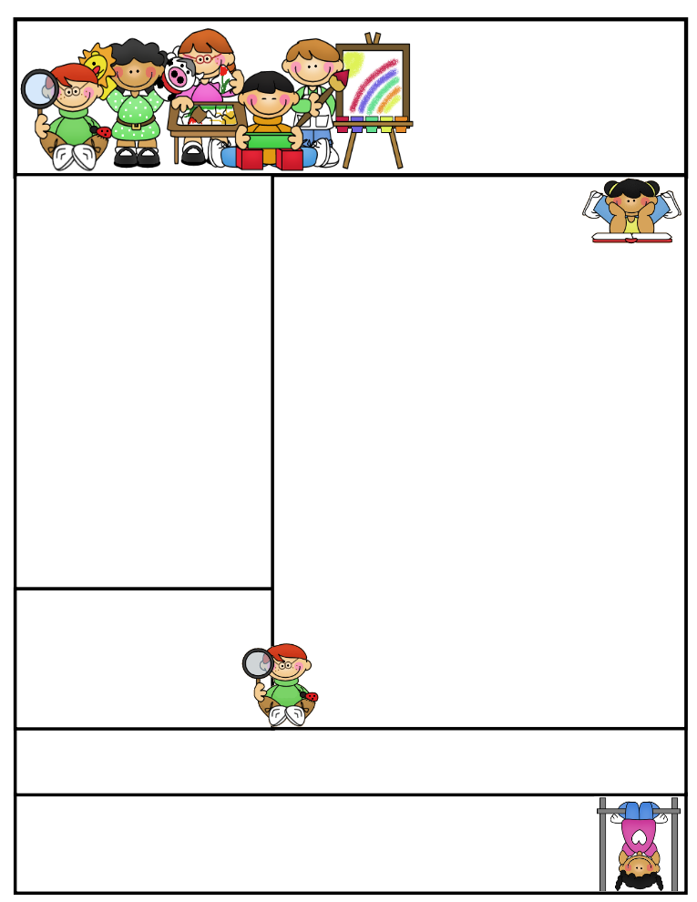

Coming to School and Dismissal

School begins at **8:20 a.m.** Please arrive at school by 8:15 a.m. Drop your child off at the school entrance doors.

Dismissal is at **3:30 p.m.** Please wait for your child to leave the classroom and pick him/her up downstairs in the gym at the end of the day.

**Please note that every minute of our day counts! We would appreciate if you could pick up your child after 3:25.**

**If your child needs to leave early for any reason, please send a signed note stating the reason for early release and inform the office.

**Eid Mubarak!**

We celebrated Eid and had a wonderful Eid party. JazakAllah Khair to all the parents for sending treats and snacks!

**Grade One  
Newsletter**

October 2015

Check us out on the web! Go to <http://ifs1a2015.weebly.com/> to see latest updates, pictures of our class, helpful hints, and much more!

Sr. Sana Siddiqui Email address: sanasiddiquiali@gmail.com  
Islamic Foundation Webpage: www.myifs.ca  
441 Nugget Ave.  
416 321-3776

October News

Assalamu Alaikum Wa rahmatullahi wabrakatuhu!

Alhumdulillah, one month of school has passed and the grade ones are busy learning and adjusting to grade one. During the first month of school, we have reviewed many concepts from kindergarten. This helped consolidate what we have learned and prepared students for many new challenges ahead!

**Language**

We are authors! The grade ones have been very busy writing stories. We talked about catching a moment from our everyday lives, making a quick sketch, telling our story and then writing it down. At the end of our writer’s workshop, we have author’s chair where an author is picked to share their story with the class.

**Oral Communication**

We started our “In the Spotlight” presentations. Students have been bringing in three items that are special to them and sharing these things with their classmates. They are also discussing where their names come from. The chosen students for the week are listed on the October monthly calendar. Please practice with your child at home in order to reduce any nervousness.

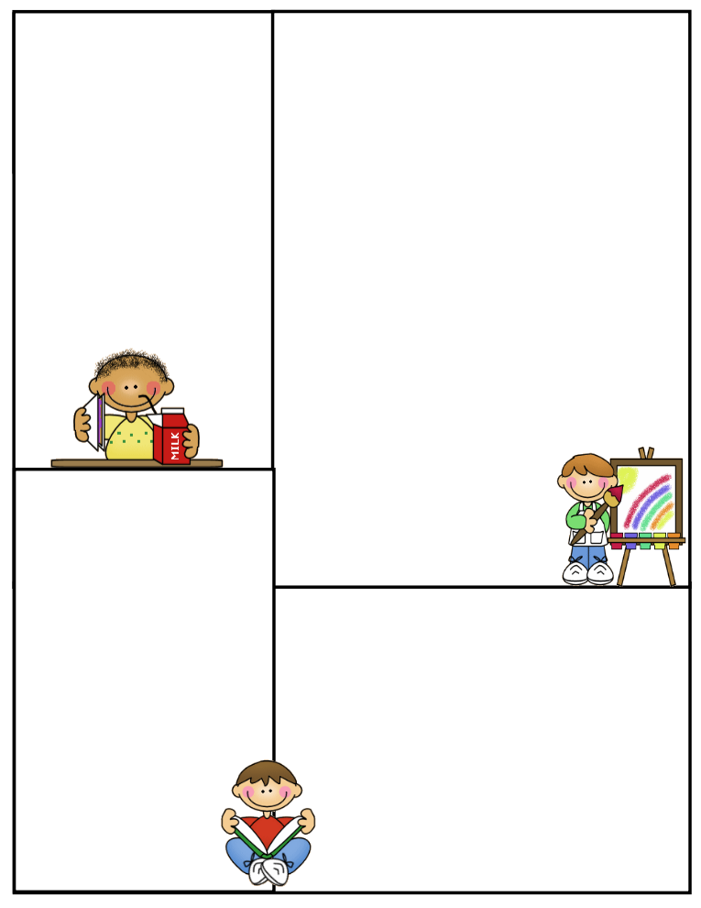

October News

**Math**

We completed a unit on sorting. We sorted all kinds of different items and tried to guess each other’s sorting rule. We also started a unit on 2D shapes. We learned to describe these shapes by their sides and corners. Later, we sorted shapes based on their attributes.

**Social Studies**

We have been learning about roles and responsibilities and how they change over time and in different situations.

**Science**

We have been discussing seasons and activities associated with each season. We also talked about the importance of the sun and how it gives us light and heat.

**Art**

We are learning about the colours of the rainbow. We will be exploring primary and secondary colours.

**Islamic Studies**

We learned about the five pillars of Islam. This month, we focused on Kalimah Shahadah and Hajj.

**Hajj Re-enactment**

Students took part in our annual Hajj

Re-enactment in the gym. It helped us

gain a better understanding of this

pillar in Islam. Visit our website to

take a look at some of our pictures!

Jazak-Allah Khair,

Sr. Sana Siddiqui

Lunch on Fridays

On Fridays, children can bring $5.00 to purchase one of the following items: Krispy’s Chicken and Fries, Popeye’s Chicken Burger, or Biryani. Pizza slices can be purchased for $2.50.

Treats

If you would like to send treats for the class in celebration of a special day or simply for the sake of sharing, please send 30 pre-packaged items or finger foods. Please refrain from sending cakes or big bags of chips. Unfortunately, serving these items takes away from our precious learning time and our planned activities for the day.

Parent Communication

Please note that I cannot speak with you in the morning before the bell or during class time, unless an appointment has been scheduled in advance. Any unscheduled interruptions may affect our planned program for the day. I hope we can work together in this regard.

If you have any questions or concerns please write to me in your child’s communication log. I will also use the log to provide you with any important information or concerns that need to be addressed.

You can also email me at **sanasiddiquiali@gmail.com.**

If you need to speak to me

directly, please call the office

at (416) 321-3776 to book an appointment.

