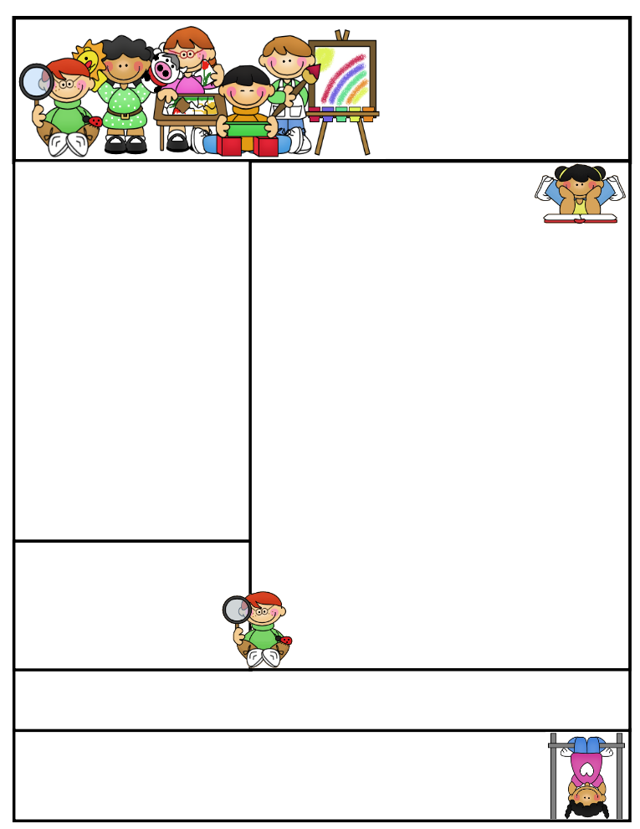

Sr. Sana Siddiqui

ifs1a2015.weebly.com  
 sanasiddiquiali@gmail.com

**The month of Feburary just flew by! February**

**was a very busy month. We went on a trip to the Ontario Science Centre and celebrated the 100th day of school.**

*Language*

In language, we finished our unit on how-to writing. Students got a chance to make pancakes and later write the steps for others to follow. Everyone really enjoyed this activity and we are thankful to our parent volunteers for enabling our students to experience this hands-on activity. We are finishing our unit on opinion writing and Inshallah will start our unit on letter writing. We will be writing friendship letters and opinion letters.

In reading we are just finishing comparing characters using traits and feelings and found examples in stories.

*Science*

Students had a great time at the Ontario Science Centre. We learned about the materials used to make paper and everyone got a chance to make a sheet of paper. We are finishing our unit on energy and Inshallah we will be making toys and looking forward to doing experiments at I am a Scientist day.

**Skating Trip to Malvern Rec Centre I am a Scientist Event**

Wednesday, March 9th 4-5 PM Tuesday March 22nd, 2015

**March Break (No School)**  **Good Friday & Easter Monday**

Monday Mar 14th, 2016 – Friday Mar 18th, 2016 Fri March 25th & Mon March 28th, 2016 (No School)

Important Dates

**Pizza Lunch (Pre-paid)**

Wednesday March 2nd, 2016

**Regional Spelling Bee - IIT**

Saturday March 5th, 2016

**Grade One  
Newsletter**

March 2016

Sr. Sana Siddiqui sanasiddiquiali@gmail.com  
Islamic Foundation ifs1a2015.weebly.com  
441 Nugget Ave.  
416 321-3776

Coming to School and Dismissal

School begins at **8:20 a.m.** Please arrive at school by 8:15 a.m. Drop your child off at the school entrance doors.

Dismissal is at **3:30 p.m.** Please wait for your child to leave the classroom and pick him/her up downstairs by the entrance doors at the end of the day.

**If your child needs to leave early for any reason, please send a signed note stating the reason for early release and inform the office.

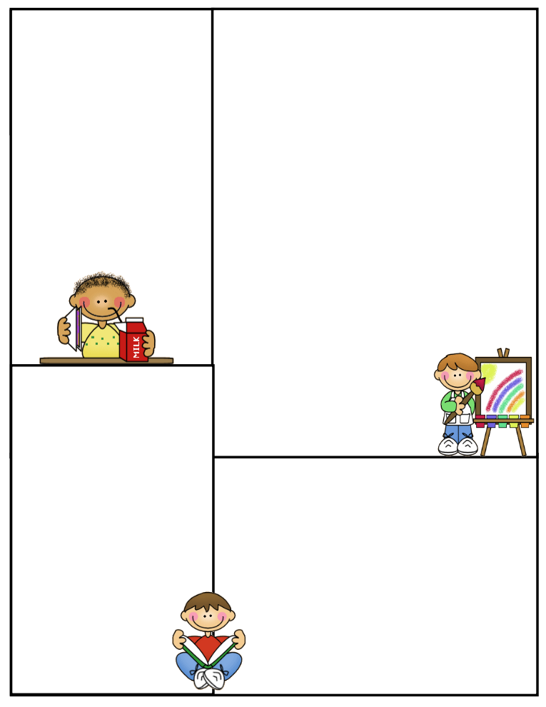

Art

In art, we are learning how to add texture to our drawings. We will be looking at Eric Carle’s paintings and try to use his style to make our own artwork. We read Maurice Sendak’s, *‘Where the Wild Things Are’* and students created their own textured monsters. We also learned about the use of different types of lines and made enjoyed making a storm scene using various types of lines.

Jazak Allah Khair,

Sr. Sana

*Math*

We are learning to identify various 3D shapes and their attributes. We sorted shapes by which ones could roll, slide or stack and made towers. We will be collecting various 3D shapes from home to build a tiny town community. We also learned about prepositions to help us with our geometry and mapping unit. Our next units will be on symmetry, measurement and area.

*Islamic Studies*

In islamic studies, we have learned about the names of Allah. We also learned about four important angels and the jobs these angels have. We discussed the books sent to Prophets (AS). We also learned about the etiquettes of Friday and wrote a how-to about what we do on Fridays. In Seerah, we are learning about the Prophet (SAW) spreading the message to family and friends and some of the hardships he faced in Makkah, the Year of Sorrow, the story of Taif, and the Isra and Miraj. We will be learning about the Islamic manners of performing bodily functions and the adaab of the masjid.

*Social Studies*

In social studies, we learned about the people and

places that comprise a community.

We invited some community helpers to our

classroom to further discuss how they help

the community. Next we will learn about

the needs of the community and how

the government provides services.

We will also be constructing a tiny town

that has all the important places a

community needs.

Lunch on Fridays

On Fridays, children can bring $6.00 to purchase one of the following items: Krispy’s Chicken and Fries, Popeye’s Chicken Burger, or Biryani. Pizza slices can be purchased for $2.50.

Treats

If you would like to send treats for the class in celebration of a special day or simply for the sake of sharing, please send 30 pre-packaged items or finger foods. Please refrain from sending cakes or big bags of chips. Unfortunately, serving these items takes away from our precious learning time and our planned activities for the day.

.

Parent Communication

Please note that I cannot speak with you in the morning before the bell or during class time, unless an appointment has been scheduled in advance. Any unscheduled interruptions may affect our planned program for the day. I hope we can work together in this regard.

If you have any questions or concerns please write to me in your child’s communication log. I will also use the log to provide you with any important information or concerns that need to be addressed.

You can also email me at **sanasiddiquiali@gmail.com**

If you need to speak to me

directly, please call the office

at (416) 321-3776 to book an appointment.