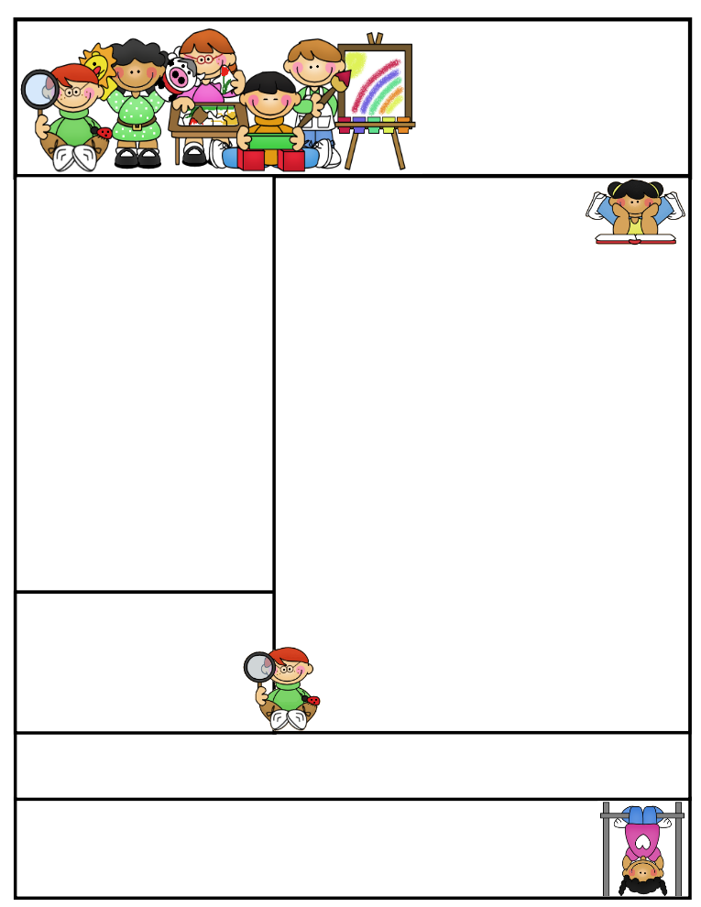

If you have any concerns about your child or any other school matter, kindly contact me to book an appointment before approaching any other school personnel, such as Sr. Zeba or Br. Yahya. I can be contacted by email or phone as below.

The Akhlaaq trait for January is sincerity.

Important Dates

**Pre-paid Pizza Lunch**

Wednesday January 6th, 2015

**Police Safety Workshop**Wednesday January 20th, 2015

**Early Dismissal**

Wednesday January 27th, 2015

Coming to School and Dismissal

School begins at **8:20 a.m.** Please arrive at school by 8:15 a.m. Drop your child off at the school entrance doors.

Dismissal is at **3:30 p.m.** Please wait for your child to leave the classroom and pick him/her up downstairs by the entrance doors at the end of the day.

**If your child needs to leave early for any reason, please send a signed note stating the reason for early release and inform the office.

January News

**December was an exciting month! We also**

**took on the role of scientists in our scientists in school workshop about energy.**

*Language*

In reading, we did response sheets to examine a story’s problem and solution, and identify the setting and main characters. As writers, we worked on recounts of moments in our lives that showed feelings. We also worked on reading responses to books. We will now be focusing on character traits from stories. We are also learning about different times of media, how they target audiences and how they influence and impact our thinking. These include ads, books, TV commercials, etc. We will be designing our own cereal boxes.

*Islamic Studies*

We learned about the different blessings Allah has given us, and about the Prophet Muhammad and the city of Makkah. We also learned about some of the Prophet’s Hadith and wrote about them in our journals. In fiqh, we learned about the steps of wudhu. In akhlaaq and adaab, we learned about the etiquettes of salaah. We will be learning about the Prophet’s marriage to Khadijah (R.A) and his family.

**Grade One  
Newsletter**

January 2016

Sr. Sana Siddiqui sanasiddiquiali@gmail.com  
Islamic Foundation ifs1a2015.weebly.com  
441 Nugget Ave.  
416 321-3776

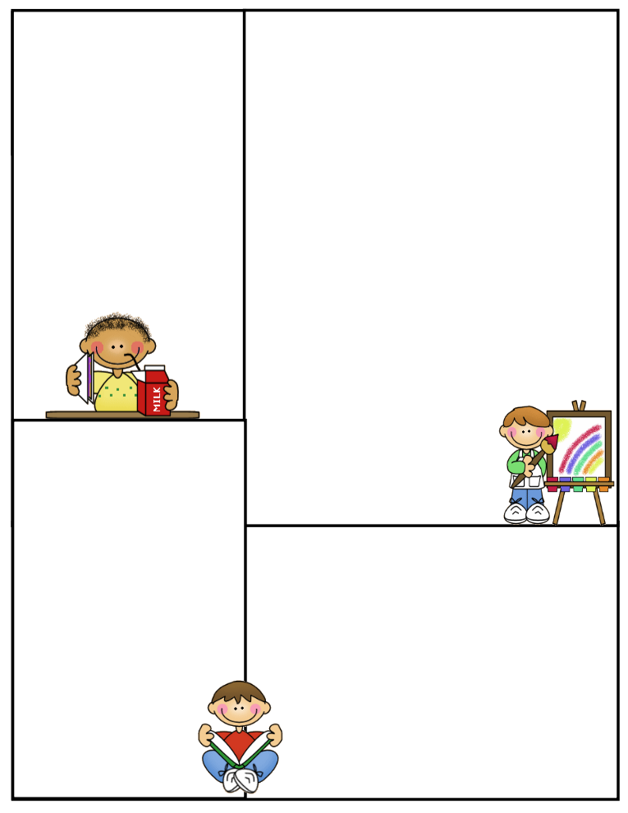



**Field Trips**

We had a successful trip to Harbourfront, the children enjoyed making collographs. Jazak Allah to all the parents who volunteered. Inshallah we have some more trips planned for second term, as well as a scientist in school visit.

**Jazak’Allah Khair,**

**Sr. Sana**

January News

*Math*

We finished number decomposition, ordinal numbers, and worked with five and ten frames. We will soon begin working with data management and probability.

*Science*

We finished our unit on seasons. We had a Scientist in School workshop to introduce our students to a new unit on energy. The students enjoyed painting a picture using solar energy and seeing UV beads change colour in the sun! We will further learn how the sun is the primary source of energy, other sources of energy and how we can save energy.

*Social Studies*

We finished our unit on roles and responsibilities. We enjoyed talking about our baby pictures and discussing how our roles and responsibilities have changed since then. We also made timelines detailing important events in our lives. Next month, we will be looking at community helpers.

*Gym and Health*

We learned about fire safety and what we can do to prevent a fire in our home. In gym,  
 we practiced travelling in a variety of ways.

Lunch on Fridays

On Fridays, children can bring $5.00 to purchase one of the following items: Krispy’s Chicken and Fries, Popeye’s Chicken Burger, or Biryani. Pizza slices can be purchased for $2.50.

Treats

If you would like to send treats for the class in celebration of a special day or simply for the sake of sharing, please send 30 pre-packaged items or finger foods. Please refrain from sending cakes or big bags of chips. Unfortunately, serving these items takes away from our precious learning time and our planned activities for the day.

Parent Communication

Please note that I cannot speak with you in the morning before the bell or during class time, unless an appointment has been scheduled in advance. Any unscheduled interruptions may affect our planned program for the day. I hope we can work together in this regard.

If you have any questions or concerns please write to me in your child’s communication log. I will also use the log to provide you with any important information or concerns that need to be addressed.

You can also email me at sanasiddiquiali@gmail.com**.**

If you need to speak to me

directly, please call the office

at (416) 321-3776 to book an appointment.