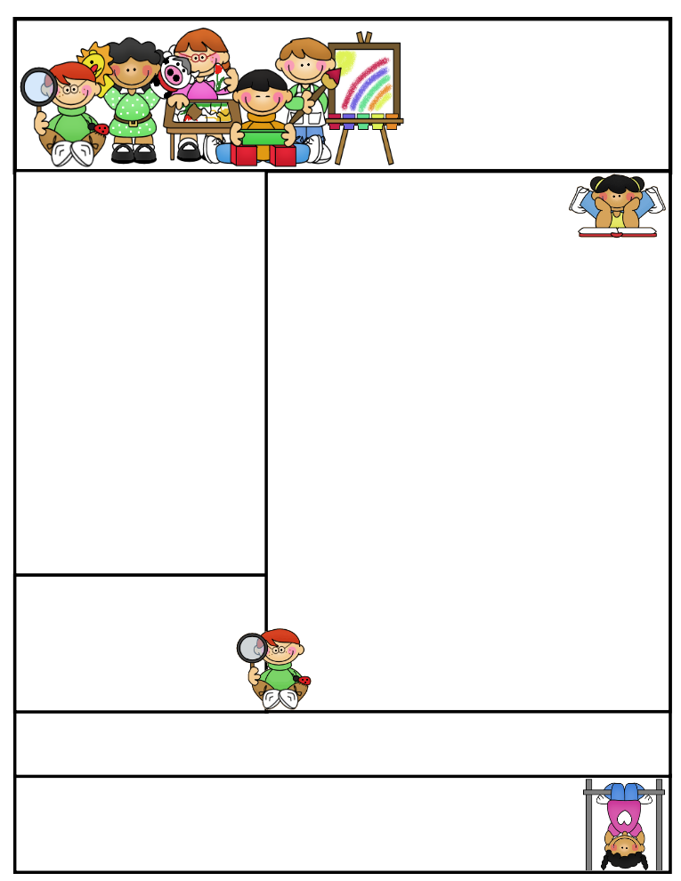

Check us out on the web! Go to ifs1a2015.weebly.com to see latest updates, pictures of our class, helpful hints, and much more!

If you have any concerns about your child or any other school matter, kindly contact me to book an appointment before approaching any other school personnel, such as Sr. Zeba or Br. Yahya. I can be contacted by email or phone as below.

*Art*

We are lines and textures. We will also be exploring paintings of Eric Carle.

February News

**Alhumdulillah, January has come to an end and the grade ones have been busy embarking on many learning adventures.**

*Language*

We started our unit on media literacy and looked at different types of media texts. We also looked at the purpose and audience of each type of text. Many of us didn’t realize that a commercial is a form of media whose purpose is to persuade us! We are now focusing on character traits from stories and character point of view. In writing we will be learning about paragraph writing that will include explaining our opinion.

*Math*

We finished our unit on addition and subtraction as well as data management and probability. The grade ones really enjoyed conducting surveys, gathering data and then presenting that data in a graph. Students also practiced reading a graph and stating what the graph tells you.

**Grade One  
Newsletter**

February 2016

Sr. Sana Siddiqui sanasiddiquiali@gmail.com  
Islamic Foundation ifs1a2015.weebly.com  
441 Nugget Ave.  
416 321-3776

Coming to School and Dismissal

School begins at **8:20 a.m.** Please arrive at school by 8:15 a.m. Drop your child off at the school entrance doors.

Dismissal is at **3:30 p.m.** Please wait for your child to leave the classroom and pick him/her up downstairs by the entrance doors at the end of the day.

**If your child needs to leave early for any reason, please send a signed note stating the reason for early release and inform the office.

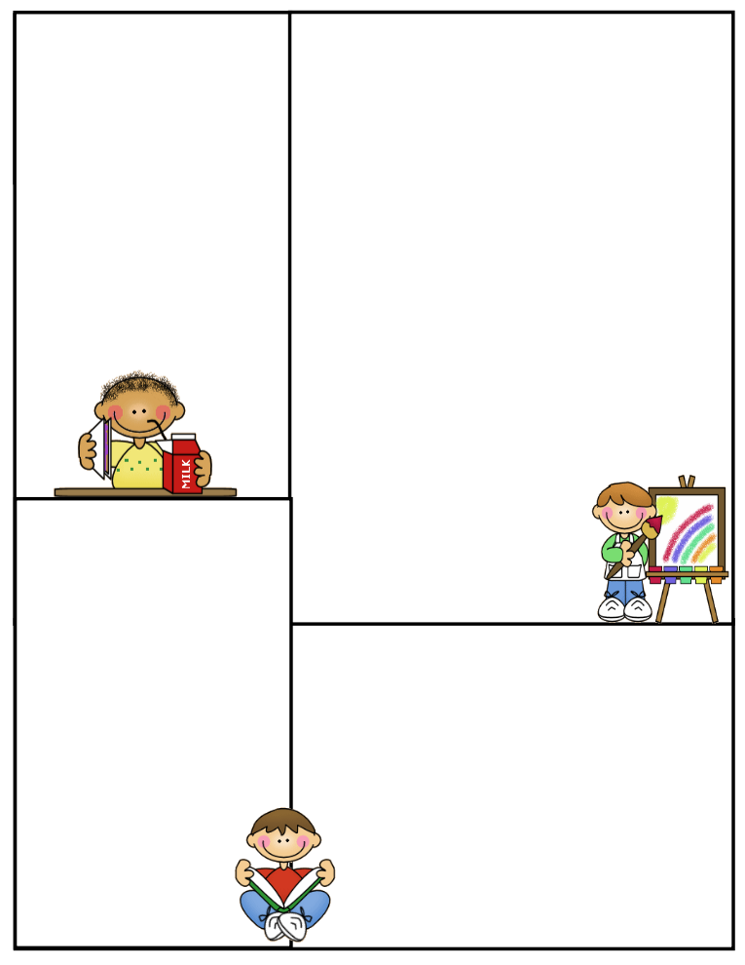

February News

*Science*

We have started a new unit on energy. We looked at how the sun is the most important source of energy. We brought in toys and discussed where each toy gets energy to work. Next, we will be looking at how we can save energy at home, in class and in the whole masjid! We will also visit the Science Centre and do hands on activities to learn about energy and its impact on our lives. We will also be making toys and exploring energy required to use our toys.

*Health*

We looked at hazardous products in the home and how to stay safe from these products. In February, we will be looking at Hygienic procedures which includes keeping our teeth clean as well as washing our hands.

*Islamic Studies*

We learned seven names of Allah and studied the early childhood of the Prophet (SAW). We sang a song about Muhammad (SAW) to help us remember the names of members of his family. We also learned about the Prophet’s marriage to Khadijah (R.A) and his family. In February we will be learning about Angels and Allah’s  
books and the four prophets that were  
given books.

*Social Studies*

We are learning about the community helpers  
and the needs of a community.

Important Dates

* **Gr. 1 and 2 Bake Sale**

Tuesday, Feb. 2, 2016

* **Preordered Pizza Lunch**

Thursday, Feb. 4, 2016

* **Report cards sent home**

Friday, Feb. 5, 2016

* **Trip to Ontario Science Centre**

Monday, Feb. 8, 2016

* **Parent Teacher Interviews (with appointments)**

Wed., Feb. 10th & Thurs., Feb.11th, 2016

* **Family Day (School Closed)**

Monday, Feb. 15th, 2016

* **Scholastic Book Fair**

Tuesday, Feb. 23rd till Monday, Feb. 29, 2016

**Early Dismissal**

Thursday February 26th, 2015  
***\*\*Please see our February monthly calendar for dates of tests***

**Jazak’Allah Khair,**

**Sr. Sana**

Lunch on Fridays

On Fridays, children can bring $6.00 to purchase one of the following items: Krispy’s Chicken and Fries, Popeye’s Chicken Burger, or Biryani. Pizza slices can be purchased for $2.50.

Treats

If you would like to send treats for the class in celebration of a special day or simply for the sake of sharing, please send 30 pre-packaged items or finger foods. Please refrain from sending cakes or big bags of chips. Unfortunately, serving these items takes away from our precious learning time and our planned activities for the day.

Parent Communication

Please note that I cannot speak with you in the morning before the bell or during class time, unless an appointment has been scheduled in advance. Any unscheduled interruptions may affect our planned program for the day. I hope we can work together in this regard.

If you have any questions or concerns please write to me in your child’s communication log. I will also use the log to provide you with any important information or concerns that need to be addressed.

You can also email

me at sanasiddiquiali@gmail.com

If you need to speak to me

directly, please call the office

at (416) 321-3776 to book an appointment.