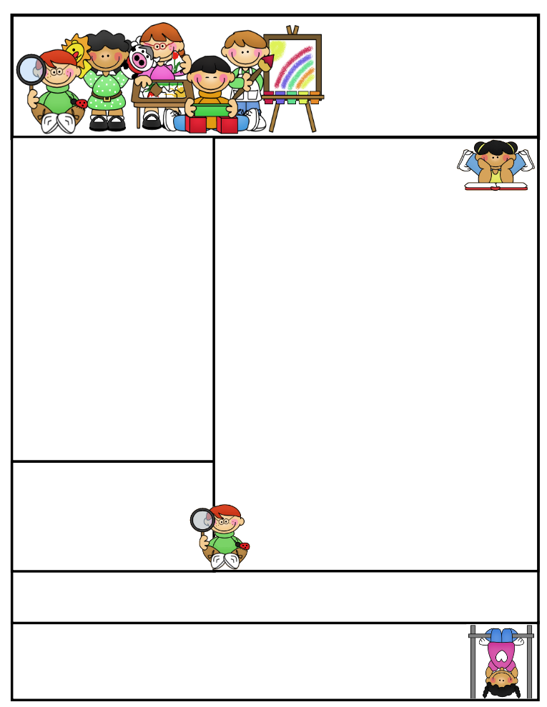

Important Dates

**Pizza Lunch**

Wednesday, December 2nd, 2015

**Harbourfront**

Tuesday, December 15, 2015

**Last Day of School**

Friday, December 18th, 2015

**School re-opens**

Monday, January 4th 2016

December News

The snack program for the month of November was a huge success! We saw students munching down lots of vegetables including celery and broccoli! All of this healthy food will give our grade one students a boost of brain power! Please note, we will not be providing snacks for the month of December due to cost constraints. However, we would like to continue the snack program for the rest of year. Please let us know if you are able to assist us in providing snacks or can volunteer to distribute snacks.

*Language*

We read number stories as part of our number unit in math. After hearing many number stories, we wrote our own! We have also started retelling stories that we have read. When retelling, we focus on the beginning (the characters and setting), the middle (the problem) and the end (the solution). We have also started writing our own stories with a beginning, middle and ending. We will continue to write about moments in our lives and focus on showing our feelings in our writing.

*Math*

In math, we finished our unit on number patterns. We learned number words and are learning to compare numbers to anchors of five and ten. We learned how to use a ten frame. We also represented numbers in different ways. We will be learning about addition and subtraction.

Check us out on the web! Go to www.grade1b-ifs.weebly.com to see latest updates, pictures of our class, helpful hints, and much more!

**Grade One  
Newsletter**

December 2015

Sr. Sana Siddiqui sanasiddiquiali@gmail.com  
Islamic Foundation http://ifs1a2015.weebly.com/  
441 Nugget Ave.  
416 321-3776

Coming to School and Dismissal

School begins at **8:20 a.m.** Please arrive at school by 8:15 a.m. Drop your child off at the school entrance doors.

Dismissal is at **3:30 p.m.** Please wait for your child to leave the classroom and pick him/her up downstairs by the entrance doors at the end of the day.

**If your child needs to leave early for any reason, please send a signed note stating the reason for early release and inform the office.

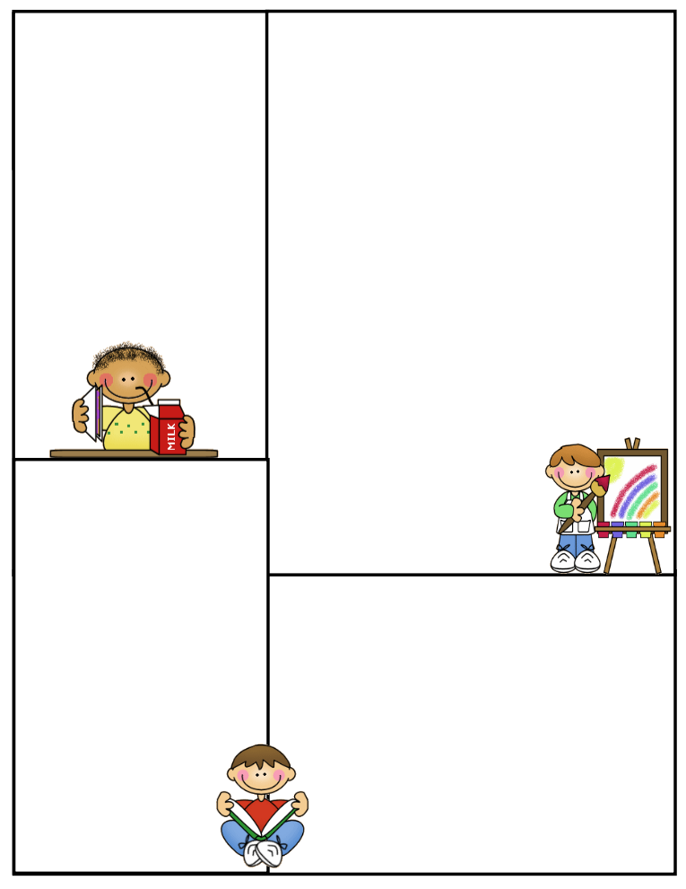

Winter Break is coming!

The December winter break is fast approaching. If you are planning to leave early for a trip, please let me know as we will be sending home a homework package for the holidays.

Parent Communication

Please note that I cannot speak with you in the morning before the bell or during class time, unless an appointment has been scheduled in advance. Any unscheduled interruptions may affect our planned program for the day. I hope we can work together in this regard.

If you have any questions or concerns please write to me in your child’s communication log. I will also use the log to provide you with any important information or concerns that need to be addressed.

You can also email

me at [**grade1ifs@gmail.com**](mailto:grade1ifs@gmail.com)**.**

If you need to speak to me

directly, please call the office

at (416) 321-3776 to book an appointment.

Lunch on Fridays

On Fridays, children can bring $5.00 to purchase one of the following items: Krispy’s Chicken and Fries, Popeye’s Chicken Burger, or Biryani. Pizza slices can be purchased for $2.50.

Trips

**Wednedsay, December 9th**- Scientists in School in the morning

**Tuesday, December 15th** – Trip to Harbourfront

December News

*Science*

In science, as part of season’s unit, we learned about how animals adapt in each season. Each group read about one animal in particular and then did a paper slide presentation showing how the animal changes in each season. We also started a season’s book showing how the weather, plants, people and activities change in each season. We will be learning about energy in our lives.

*Islamic Studies*

We learned about our duties to parents, teachers and our neighbours. We also learned about appropriate greetings to use in our everyday speech such as Insha Allah when we plan to do something. We will be learning about the steps of wudhu and specific names of Allah.

*Social Studies*

We are learning about relationships and how our relationships are different with family, friends, and teachers.

*Gym and Health*

In gym, we practiced travelling in a variety of ways.

We will be learning about fire safety and what we can do to prevent a fire in our home.