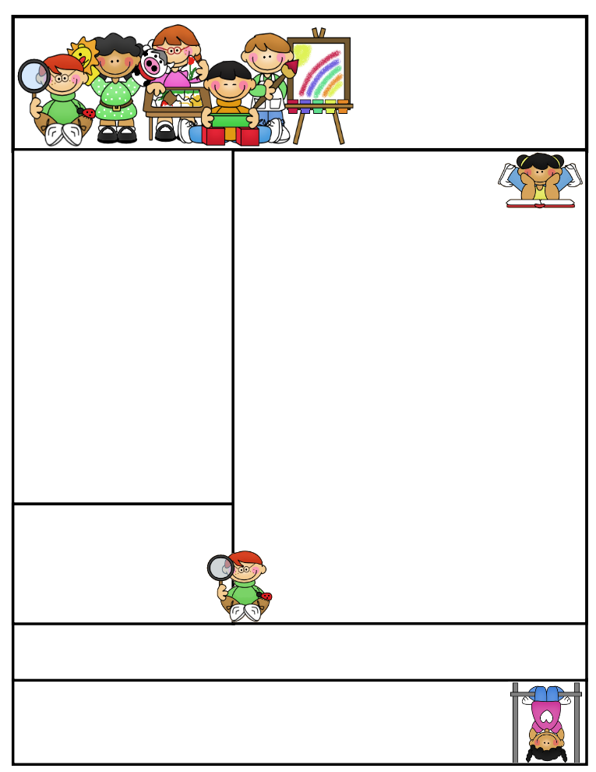

**Grade One  
Newsletter**

April 2016

April News

**The month of March just flew by! March was**

**a very busy month. We made toys for our “I am a scientist” day and had a lot of fun building structures such as stools for Scientist in School.**

*Language*

In language, we have finished our character inference package and comparing characters to each other in our reading. In writing, we finished doing opinion paragraphs. We have started our unit on letter writing. We will be writing letters to classmates and pen pals from another school. We will move on to writing opinion letters, and later, paragraph writing. We are also focusing on prepositions to help us with our geometry and mapping unit. In our reading, we will be relating texts to other texts, to ourselves, and to the world.

*Science*

We have started our unit on structures and materials. Students had a wonderful time in our scientist in school workshop. They got hands on experience building structures, learning about the jobs of structures and understanding what makes a structure stable. In class, we will test out various materials to see which were waterproof and which were not. Our next unit will be about living and non-living things.

*Health*

We learned about oral hygiene and its importance.  
 We will next be discussing proper handwashing.

Coming to School and Dismissal

School begins at **8:20 a.m.** Please arrive at school by 8:15 a.m. Drop your child off at the school entrance doors.

Dismissal is at **3:30 p.m.** Please wait for your child to leave the classroom and pick him/her up downstairs by the entrance doors at the end of the day.

**If your child needs to leave early for any reason, please send a signed note stating the reason for early release and inform the office.

Important Dates

**Pizza Lunch (Pre-paid)**

Wednesday April 6st, 2016

**Bake Sale**

Thursday April 14th, 2016

Check us out on the web! Go to www.grade1a-ifs.weebly.com to see latest updates, pictures of our class, helpful hints, and much more!

Sr. Sana Siddiqui sanasiddiquiali@gmail.com  
Islamic Foundation ifs1a2015.weebly.com  
441 Nugget Ave.  
416 321-3776

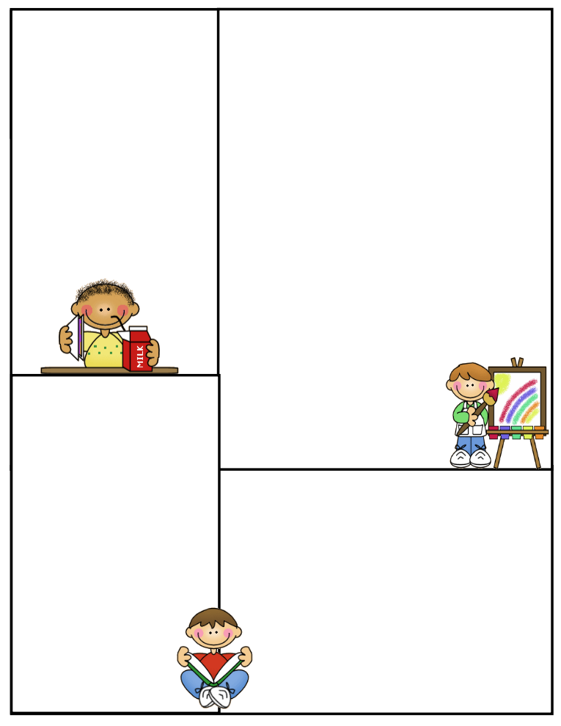

Important Dates (cont’d)

**PD Day**

Friday April 22nd, 2016 (No School)

***\*\*Please see our April monthly calendar for dates of tests.***

**Jazak’Allah Khair,**

**Sr. Sana**

April News

*Math*

We learned about 3D shapes and their properties, and about symmetry. Our current unit is measurement of length, mass, and capacity. In may we will begin discussing time and money.

*Islamic Studies*

In islamic studies, we discussed the second half of the Prophet’s (pbuh) mission in Makkah including the Year of Sorry and the Night Journey and Ascension. We are now learning basic Fiqh rules about using the bathroom.

*Social Studies*

In social studies, we are learning about the needs of a community and the people and places that comprise a community. We will be constructing a tiny town that has all the important places a community needs. Next we will be learning about reading and constructing maps.

Lunch on Fridays

On Fridays, children can bring $6.00 to purchase one of the following items: Krispy’s Chicken and Fries, Popeye’s Chicken Burger, or Biryani. Pizza slices can be purchased for $2.50.

Treats

If you would like to send treats for the class in celebration of a special day or simply for the sake of sharing, please send 30 pre-packaged items or finger foods. Please refrain from sending cakes or big bags of chips. Unfortunately, serving these items takes away from our precious learning time and our planned activities for the day.

Parent Communication

Please note that I cannot speak with you in the morning before the bell or during class time, unless an appointment has been scheduled in advance. Any unscheduled interruptions may affect our planned program for the day. I hope we can work together in this regard.

If you have any questions or concerns please write to me in your child’s communication log. I will also use the log to provide you with any important information or concerns that need to be addressed.

You can also email me at [**sanasiddiquiali@gmail.com**](mailto:sanasiddiquiali@gmail.com)**.**

If you need to speak to me

directly, please call the office

at (416) 321-3776 to book an appointment.